TLF / CEF: Calculation Sheet User Manual

APPROVAL
Title | TLF / CEF: Calculation Sheet User Manual
Issue Number | ​ | Revision Number | ​
Author | Loris Franchi | Date | 30/03/2022
Approved By |  | Date of Approval

CHANGE LOG
Reason for change | Issue Nr | Revision Number | Date

CHANGE RECORD
Issue Number | ​ | Revision Number | ​
Reason for change |  | Date | Pages | Paragraph(s)

DISTRIBUTION
Name/Organisational Unit

Table of Contents
1. Introduction 4
1.1. Calculation Sheets characteristics 4
1.2. Subsystems description 6
1.2.1. ADCS 6
1.2.2. Communication System 11
1.2.3. EPS 15
1.2.4. Propulsion System 17

- Introduction
The design of any space mission involves many different disciplines cooperating and communicating to achieve a shared goal. Consequently, there is a certain number of subsystems that constitute the hardware and the software of the project and need to be designed and sized properly to accomplish requirements and constraints.
During first phases of a project, a huge number of design data needs to be collected and exchanged amongst subsystems experts. One possible way to do so is using calculation sheets, Excel format sheets in which it is possible to insert data and compute parameters and key figures of use throughout design interactions.

  - Calculation Sheets characteristics
In the Training and Learning Facility (TLF) and Concurrent Engineering Facility (CEF), different domain of expertise has its own calculation sheet, composed by different sections (sheet) in which key design parameters are estimated.
In every subsystem sheet there are also a dedicated pages for the product tree, one for design constants and one for change logs.
Parameters and quantities can be either manually input, calculated from formulas or retrieved from other sheets or COMET pulled data. Theoretical models on which sheets are built around are taken from Space Mission Analysis and Design third edition (edited by Larson and Wertz). Reference to SMAD formula is found in cells comments.
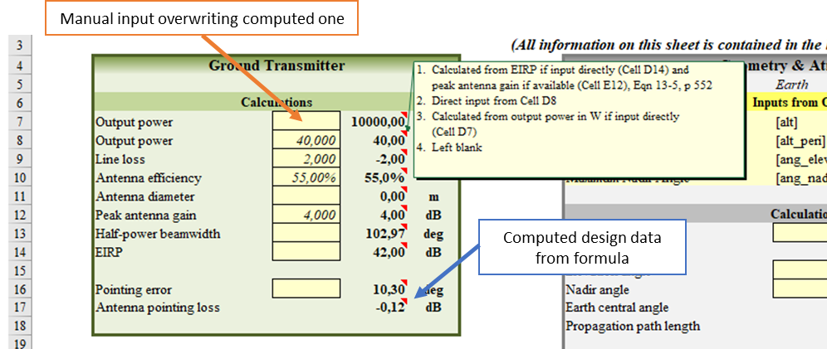
Figure 1 Overview of cell calculation sheet proprieties
Operative modes are also considered. A section for trade-off is present too, making possible the comparison of key criteria computed for various options and configurations to choose the most suitable one (Figure 1).
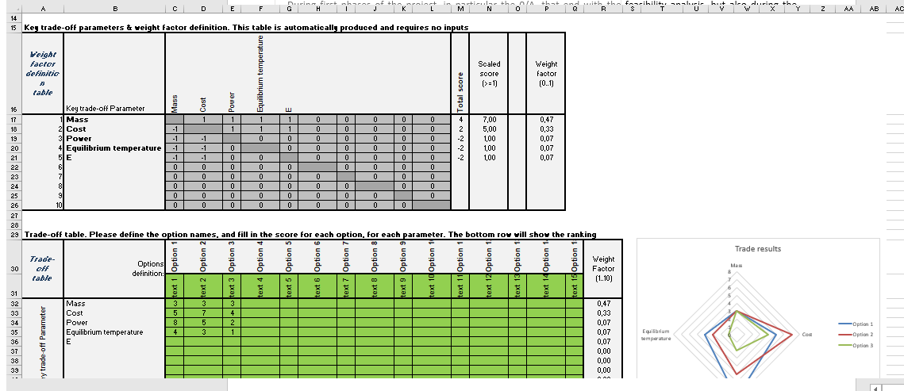
Figure 2 Trade Off Sheet
COMET data can be used in the calculation thanks to cell tags generated when pulling data from server. When doing so it is recommended to input COMET data in manual input cells.
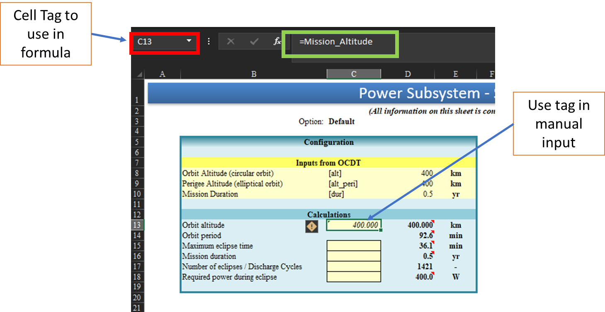
Figure 3 COMET data and excel ID tags example

When pondering about formula items it is recommened to use the “trace dependences” function of excel to better understand which data is use in the corrisponding formula.

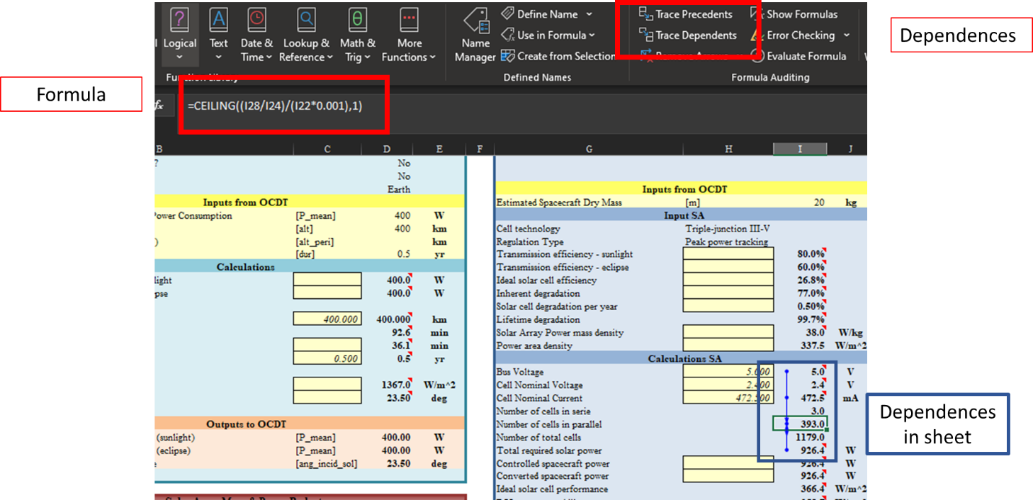
Figure 4 Trace dependances

  - Subsystems description (DRAFT VERSION)
    - ADCS
In order to design this subsystem, some definitions and concepts are needed: first of all, mass properties shall be specified, in particular the location of the centre of gravity of the S/C, the components of the inertia matrix and the direction of principal axes (actually that direction for which inertia matrix is diagonal and inertia products are null). In fact in space, where torques are typically small are S/C is unconstrained, angular momentum and its conservation play an important role in contrasting disturbances or reorienting the system.
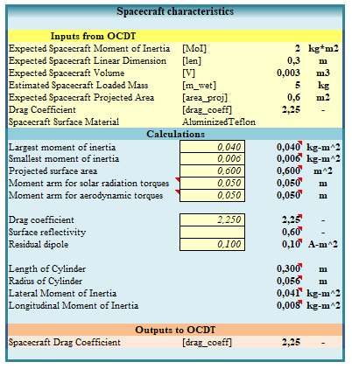
In ADCS calculation sheet we can find these geometric and inertial properties in the page “Attitude Control – Torques”, under the section “Spacecraft characteristic”
Disturbance torques to which a body in space is subject and that can affect the orientation of a S/C derived from various sources and for Earth-orbiting systems can be of four different kinds:
- Gravity gradient
- Solar radiation
- Magnetic
- Aerodynamic (for LEO missions)
Due to the non-uniformity of the gravitational field in space, the gravitational force over a S/C may not be uniform in both magnitude and direction and therefore it may results in a torque about the body Centre of Mass that tends to align the direction of the maximum inertia moment of the S/C to the local vertical. This type of disturb is constant for an Earth-oriented vehicle and cyclic for an inertially oriented one; the max value of gravity torque can be estimated with the following relation:
$$T_{g}=\frac{3μ}{2R^{3}}\left|I_{z}-I_{y,x}\right|\sin{(2θ)} [N∙m]$$
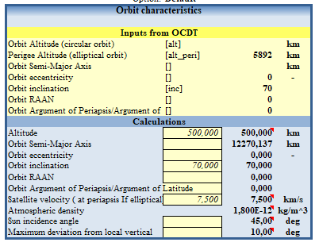
Where $μ$ is the Earth’s gravity constant (3.966*10¹⁴ ${m^{3}}/{s^{2}}$), $R$ is the orbit radius in meters, θ is the maximum deviation of the Z-axis from local vertical in radians, $I_{z}$ is the moment of inertia around Z-axis and $I_{y,x}$ is the smaller moment of inertia between that around Y-axis and that on X-axis, all in kg*$m^{2}$. The level of this torque will be low unless a long thin configuration is used or in case of tethered satellites. Orbital parameters like the orbit radius or the deviation θ are included in the “Orbit characteristics” section in the “Attitude Control – Torques” page while moment of inertia are retrieved from the “Spacecraft characteristics section”.
Solar radiation produce a force on surfaces of the S/C (i.e. a pressure), that is function of its distance from the Sun and of its geometry, in terms of cg location and moment arm (especially for large flat surfaces relatively far from cg , such as solar arrays). This disturb arises since light carries momentum, and when it is reflected at a surface it results in an exchange of momentum with the surface. SRP also depends on the type of surface being illuminated through the material reflectivity. It can be calculated as following:
$$T_{sp}=F\left(c_{ps}-cg\right)=\frac{F_{s}}{c}A_{s}(1+q)\cos{i [N∙m]}$$
Where $F_{s}$ is the solar constant (1.367 $W/{m^{2}}$), c is the speed of light (3∙10⁸ $m/s$), $A_{s}$ is the surface area, $c_{ps}$ is the location of the center of solar pressure, q is the reflectance factor (ranging from 0 to 1), and I is the angle of incidence of the Sun. This kind of torque is cyclic on Earth-oriented satellites and constant for solar-oriented ones.
The magnetic field generated by a S/C interacts with the local field from the Earth and thereby exerts an external cyclic couple on the vehicle. We can represent the S/C’s magnetism as a dipole and so calculate the torque as:
$$T_{m}=DB=D\left(2\frac{M}{R^{3}}\right) [N∙m]$$
Where D is the residual dipole of the S/C in $A/{m^{2}}$, B is the Earth’s magnetic field that can can be approximated as above for a polar orbit to half that at the equator, M is the magnetic moment of the Earth (7.96∙10¹⁵ $tesla∙m^{3}$) and R is the radius from the Earth center to S/C in m.
Aerodynamic torque is generated by the drag force of the atmosphere and for this reason it is to consider only for low altitude orbits, varying significantly with solar activity. It can be calculated as following:
$$T_{a}=F\left(c_{pa}-cg\right)=\frac{1}{2}ρC_{d}AV^{2}\left(c_{pa}-cg\right) \left[N∙m\right]$$
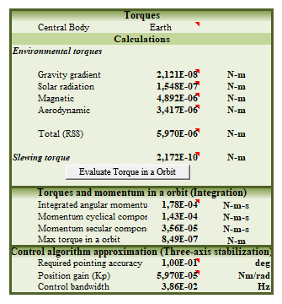
Where $ρ$ is the atmospheric density, $C_{d}$ is the drag coefficient (normally ranging from 2 to 2.5), A is the surface area, V is the S/C velocity and $c_{pa}$ is the center of aerodynamic pressure. This kind of torque is constant for Earth-oriented S/Cs and variable for inertially oriented vehicles.
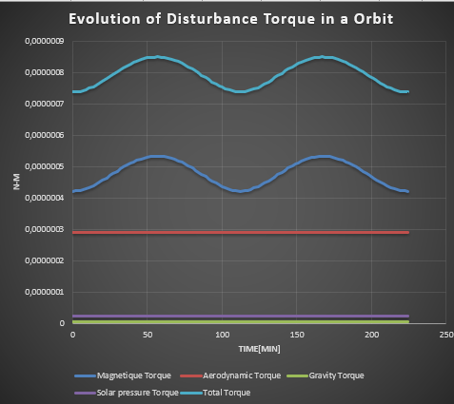
All the necessary quantities to estimate the four kind of disturbances can be found either in “Spacecraft characteristics” or in “Orbit characteristics” while the results are calculated in the section called “Torques”,where the button “Evaluate Torque in a Orbit” generates a graphic representing the evolution of the disturbances along the orbit
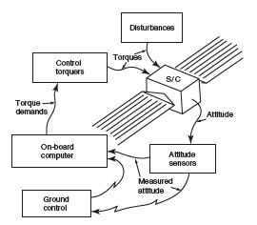
Once all these disturbances have been evaluated, the total disturb can be computed as the root sum square of values and the total torque in an orbit by integration, as well as it is done in the section “Torques”
Even if disturbances can generate also from internal motions, like the sloshing of liquids or misalignment of thruster or dynamics of flexible parts, in the preliminary design phase but especially for cubesat missions this kind of torques can be neglected.
From the practical point of view, torques from disturbances and from torquers are detected by the sensors, which send outputs to computers on-board and at the ground control station, which use the information to determine the torques needed to be applied to the structure in order to maintain the desired attitude.
What is necessary to size are so sensors and actuators (torquers); for a preliminary design sensor can be sized in terms of mass, power and number only, because being standard components, they don’t require many other specifications: this sizing is done in the page “ Attitude Control – Sizing” under the section “Sensors” . Typical sensors used in this subsystem are Earth sensors, Sun sensors, gyroscopes, magnetometers and star sensors.
Note that estimation is done based on statical data from Small Satellites. It does not fit with CubeSats estimation, it is recommended to look for COTS components instead!

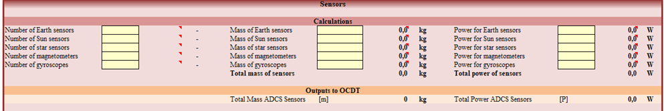
For actuators instead, the sizing should be a bit more accurate and should include dimensions, required angular momentum (for reaction and momentum wheels), duty cycle, burn time (for thrusters), and number and area of coils for magnetic torquers. The mass and required power of each of these components clearly should computed and considered in the total mass and power budgets of the S/C. The calculations needed to correctly size most common actuators are done in the “Attitude Control – Sizing” page of the ADCS sheet
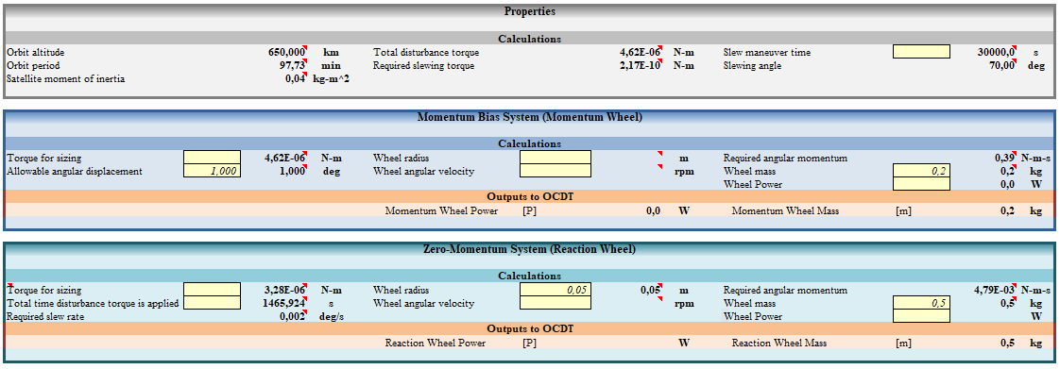
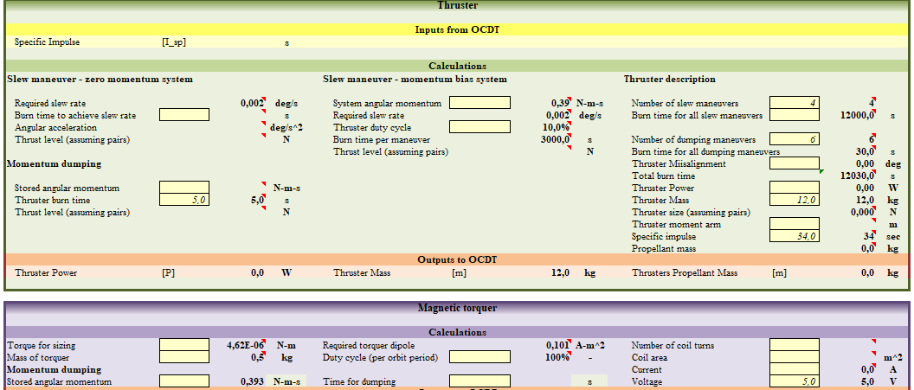
In the concept of our sheet, disturbances are opposed by the momentum wheel (for a momentum bias configuration) or by the reaction wheel (for a zero-momentum system), both being dumped either by thruster or by a magnetorquers. Since a typical Cubesat mission isn’t provided of thrusters, reaction wheels can be dimensioned for both contrasting disturbances and performing angular manoeuvres, but for any other kind of mission that is provided of propulsion, under the “Thruster” section the dimensioning for manoeuvres is inserted.
    - Communication System
The first step in sizing the communication system of a S/C is to design the communication architecture, as the arrangement and configuration of ground stations and satellites included in the space system, and surely also the network of links and how they will be performed. The possible architecture should be selected according to the requirements and constraints of the project, then the data budget can be calculated, and every link of the network designed.
Depending on the type of communication, whether uplink or downlink or interlink, both receiver and transmitter should be designed for both ground and space segment. The architecture may be affected by data processing onboard the satellite, but usually, the collected data are transmitted directly to the user via downlink, unless the system contains a great number of ground stations, so processing the data onboard may be more convenient rather than having a processor for every ground station’s user or sending great amount of data to be processed. There are many different criteria for choosing the architecture, and after the selection, some parameters have to be computed.
To perform link design, it is possible to use a relationship between data rate, antenna size, propagation path length and transmitted power to calculate the signal-to-noise ratio of the system, defined as the ratio between the receiver energy-per-bit and the noise density:
$$\frac{E_{b}}{N_{o}}=\frac{PL_{t}G_{t}L_{s}L_{a}G_{r}}{kT_{s}R}$$
It is the so called link equation, where P is the transmitter power, $L_{t}$ is the line loss between transmitter and antenna, $G_{t}$ is the transmitting antenna gain (defined as the ratio of power radiated to the center of the coverage area to the power radiated by an isotropic antenna), $L_{s}$ is the space loss, $L_{a}$ is the transmission path loss, $G_{r}$ is the receiving antenna gain, k is the Boltzmann’s constant, $T_{s}$ is the system noise temperature and R is the data rate. The product $PL_{t}G_{t}$ is the EIRP (Effective Isotropic Radiated Power), measured in Watts, and it is the hypothetical power that would have to be radiated by an isotropic antenna to give the same ("equivalent") signal strength as the actual source antenna in the direction of the antenna's strongest beam. Rain absorption is also to consider as a significant factor for radio frequencies above 10 GHz. Another quantity to estimate is the pointing error of the antenna, caused by wind gusts on the ground or stabilization errors on the S/C that generate a pointing offset from the beam centre, translating it into a pointing loss $L_{θ}$, calculated as follow:
$$L_{θ}=-12{(e/θ)}^{2}$$
Where θ is the antenna half-power beamwidth (for a circular antenna beam, θ is the angle across which the gain is within the 50% of the peak gain), and e is the pointing error. Θ is estimable as $\frac{21}{f_{GHz}D}$, where $f_{GHz}$ is the carrier frequency in GHz and D is the antenna diameter in meters. All these quantities are related among them and can be inserted in the Communication System sheet in every page for both receiver and transmitter.

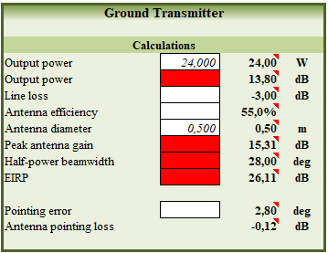

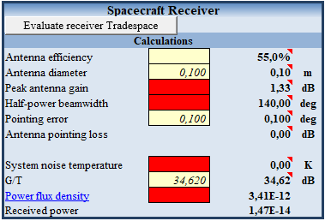

Considering the receiver, we need to estimate the system noise temperature $T_{s}$, that is the sum of a number of contributions from various sources like the galactic noise, the noise radiated by clouds and rain in the propagation path, the Solar noise and the man-made noise and it is function of the frequency, computable using another parameter, the sensitivity of the receiving station G/T, linked to the noise temperature $T_{s}$ by the relationship:
$$\frac{G}{T}=G_{r}-10\log{ T_{s}}$$
The rain attenuation causes an increase in system noise temperature, which entity depends on the system noise in clear weather: the resulting increase in the system noise temperature is evaluated in the section “Geometry & Atmosphere” of each page by the formula:
$$∆T_{s}=T_{0}(1-{10}^{{L_{a}}/{10}})$$
Where $T_{0}$ is the temperature of the rain, usually assumed to be 290 K, and $L_{a}$ is the rain attenuation, expressed in dB.
The whole process of calculation is applicable to both downlink and uplink communication.
In order to complete the link design, in each page of the CommSys sheet a section for signal characteristic is present
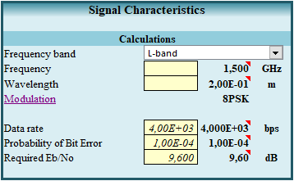
Here, as you can see, it is possible to insert the frequency band of the signal and carrier frequency with the corresponding wavelength. The modulation is the process by which it is possible to translate the information contained in the data signal in one or more parameters of the carrier signal like the amplitude, the phase, the frequency and the polarization. For space system, phase or frequency modulation are the most used inasmuch the transmitter can operate at saturation for maximum power efficiency. A spread modulation technique is the Phase-Shift Keying (PSK), where the phase is changed to represent the data signal by viewing as conveying the information either the phase itself or the change in phase. In particular, the BPSK modulation, that is the simplest form or PSK, uses two phases which are separated by 180° and is able to modulate 1 bit/symbol, so it is unsuitable for high data-rate applications (it sets the carrier phase at 0° to transmit a binary 0 and at 180° to transmit a binary 1). Then there is the QPSK modulation, that takes two bits at a time to define one of the four symbols, corresponding to one of the four carrier phases among 0, 90, 180 and 270 degrees. In the same way but taking three bits at a time is the 8PSK modulation. The last option considered in the sheet is the 16QAM modulation (Quadrature amplitude modulation), an amplitude modulation technique, taken into account only if required data-rates are beyond those offered by 8PSK (for this reason it is seldom used, especially for Cubesat applications).
To demodulate a digital bit reliably, the amount of energy received for that bit, the $E_{b}$, must exceed the noise spectral density, $N_{0}$, by a specific quantity, so the quantity ${E_{b}}/{N_{0}}$ must be derived in order to ensure a certain BER (Bit error rate), a quantity that gives the probability of receiving an erroneous bit. For instance, a BER of 10⁻⁵ means that, on the average, only one bit will be in error for every 10⁵ bits received, and to achieve that, if a BPSK modulation is used, a ${E_{b}}/{N_{0}}$ of 9.6 dB is required.
Once all parameters for both receiver and transmitter have been inserted and losses have been estimated, the resulting ${E_{b}}/{N_{0}}$ can be calculated, using either the above mentioned equation, or, if all the quantities are expressed in dB, the following one:
$${E_{b}}/{N_{0}}=EIRP+ L_{pr}+L_{s}+L_{a}+G_{r}+228.6-10\log{T_{s}-10\log{R}}$$
The required $\frac{E_{b}}{N_{o}}$ should be compared to that obtained using data from sizing, and depending on the type of communication (data, telemetry, command) an adequate margin should be imposed in order to evaluate if the link margin is closed.
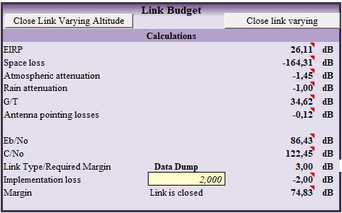
In the sheet, through the use of Excel Macros, it is possible to close the link varying either the altitude of the satellite or the transmitter antenna diameter.

    - EPS
The first step in sizing the electric propulsion system of a satellite is to evaluate the power budget: the total power demand required from all subsystems and payloads to satisfy in both sunlight and eclipse phases. The typical configuration adopted in most missions is to use solar panels in order to exploit solar energy when the S/C is in sunlight and to recharge secondary batteries. A secondary battery for energy storage can convert chemical energy into electrical energy during discharge and electrical energy into chemical energy during charge, repeating this process for thousands of cycles. These batteries recharge in sunlight and discharge in eclipse. So solar panels are the primary source of energy and batteries are the secondary ones, usable for peak-power demands and for eclipse periods.
Solar arrays should be sized for the most demanding condition of power, while secondary batteries to provide energy in the worst condition of maximum eclipse time.
In the "Power Budget" page all operative modes of the mission are considered, specifying for each of them the state of subsystems (ON/OFF) and their duty cycles. The budget is estimated considering the worst case (the highest value of power consumption).
Once BOL and EOL power loads are identified, we must design and size the solar arrays that meets that demand.
In the "Solar Array" page it is possible to choose among five different types of cell technology and two different regulation types. Therefore, the power that solar arrays must provide during daylight to power the S/C for the entire orbit is evaluated according to the formula:
$$P_{sa}=\frac{\frac{P_{e}T_{e}}{X_{e}}+\frac{P_{d}T_{d}}{X_{d}}}{T_{d}}$$

Where P_{e} and P_{d} are the power requirements during eclipse and daylight, T_{e} and T_{d} are the eclipse and daylight periods per orbit, and X_{e} and X_{d} represent the transmission efficiency of the paths from solar arrays to the batteries (during eclipse) or directly to the loads (during daylight).
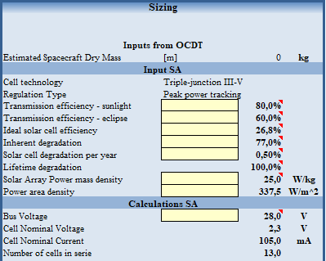
Once characteristics of cells are defined the required number and area are evaluated, so it is also possible to estimate the mass of solar panels, of regulators and wirings.
Once the type of secondary batteries is selected their size must be calculated in terms of battery capacity through the formula:
$$C_{r}=\frac{P_{e}T_{e}}{\left(DOD\right)Nn}$$

Where N is the number of batteries, n is the transmission efficiency and DOD is the depth-of-discharge, defined as the percent of total battery capacity removed during a discharge period and calculable as in Table 2.

Battery Technology | Depth of Discharge
Nickel-Hydrogen | DOD = -0,2818 log10 (cycles) + 1,68181
Nickel-Cadmium | DOD = -0,2818 log10 (cycles) + 1,46

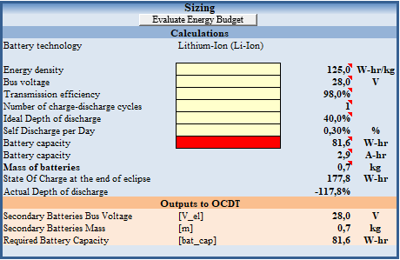

    - Propulsion System
Once the type of propulsion, either chemical or electric, is selected, we need to collect project requirements from mission analysis, in particular in terms of delta-V and specific impulse, and after some calculations we may size the system, design the propulsor and estimate the storage.
We can write the thrust delivered by the rocket as
$$F=\dot{m}V_{e}$$
Where $\dot{m}$ is the exhaust mass flow rate and $V_{e}$ is the exhaust velocity, typically fixed by the choice of propellant.
For chemical rockets, the Tsiolkovsky equation describes the mass needed to perform a certain ΔV in field-free space:
$$∆V=V_{e}\ln{R}$$
Where R is the ratio between the initial mass of the S/C and the mass at burn-out, that represent exactly the propellant mass depleted during the manoeuvre and is the only parameter that can be varied to accomplish the request of thrust.
If we indicate with M the vehicle mass and with $\dot{M}$ its variation along time, it is clear that $\dot{M}=-\dot{m}$.
It is useful to define another quantity, the effective exhaust velocity as
$$V_{e}^{*}=V_{e}+A_{e}\left(p_{e}-p_{a}\right)/\dot{m}$$
Where $A_{e}\left(p_{e}-p_{a}\right)$ is the resultant force on the rocket due to the pressure difference between the nozzle exit and the environment. Its maximization for a particular ΔV is essential for an efficient design.
Thrusters usually work giving impulsive actions, and for this reason, the activation time per impulse should be designed according to the required ΔV.
For a given combustion chamber pressure $p_{c}$ and mass flow rate $\dot{m}$, which determine the throat area of the nozzle according the relationship $\dot{m}=p_{c}A_{t}/c^{*}$, where $c^{*}$ is the characteristic velocity for the selected propellant, it is possible to optimize the thrust of the motor. The optimum condition is reached when the nozzle is adapted, or rather when $p_{e}=p_{a}$ and the nozzle is said to be ideally expanded. Obviously, real exhaust flow patterns deflect from this ideal behaviour, but to optimize the thrust it is necessary to design the correct nozzle expansion ratio ${A_{e}}/{A_{t}}$, from which depends the thrust coefficient $C_{F}$, according to the relationship
$$C_{F}=\frac{F}{p_{c}A_{t}}=C_{F}^{0}+\frac{A_{e}}{A_{t}}(\frac{p_{e}}{p_{c}}-\frac{p_{a}}{p_{c}})$$
Where $C_{F}^{0}$ is the thrust coefficient for ideal expansion.
What characterizes the performance of the engine in terms of consumed propellant is the specific impulse $I_{sp}$, defined as the total impulse per unit propellant weight consumed and given by:
$$I_{sp}=\frac{I}{M_{p}g_{0}}$$
That for constant thrust and exhaust mass flow rate becomes:
$$I_{sp}=\frac{F}{\dot{m}g_{0}}$$
All the necessary calculations are made in the section “Sizing” and “Propulsion System Design” of the sheet, in which useful graphics are made in order to determine the optimal specific impulse and mass of the system for certain mission requirements and inputs from mission analysis (like ΔV or the mass margin).
The storage and feed subsystem needs to be sized too, in terms of mass and volume of the tanks.
Concerning electric propulsion, we talk not of thrust but of power, as the output of the power-plant, related to the exhaust velocity by the following expression:
$$W=1/2\dot{m}V_{e}^{2}$$
The power output can be related to the power-plant mass by the specific power α as $M_{W}=αW$.

